Scope of Services / Project Narrative
Legal Assistance for Victims of Domestic Violence, Sexual Abuses, Dating, Stalking

Implementing Entity: ORPE Human Rights Advocates
- Problem for intervention
- Need to be improved
- Purpose
- Activities
- Implementation timeline for accomplishing key grant activities
- Intended outputs (Products)
- Inputs
- Capability
- Data collection procedure
- Collaborative activities
I. CURRENT STATE OF VICTIM SERVICES
Currently, the Office of the Chief Legal of the Department of Legal Services of the ORPE Advocates houses the Victim Coordinator, who is the only full-time employee whose role is to serve all victims of crime. Victim Coordinator is also the only support person in the Office, which means that her duties are largely related to case preparation that do not involve direct outreach to and support of victims. Victims of domestic violence and sexual assault are served by the ORPE Advocacy’s DV/SA Program, which also operates the ORPE Advocacy housing programs, which provides temporary housing for women in crisis, many of whom are victims of crime. Additionally, child victims are served by the ORPE Advocacy’s Child Program.
ORPE has a multi-disciplinary approach in providing victim services and this approach includes: Victim Services Department; Legal Services for Victims, Integrated Behavioral Health and Primary care; Supportive Social Services; economic inclusion and skills building department; and external partnerships to meet the needs of the community. ORPE currently has established advocacy services and utilizes appropriate internal departments and staff resources.

II. DESCRIPTION OF THE ISSUE
If ORPE Advocacy receives funding through this grant, the organization expects to address several gaps in victim services:
- Current Conditions of offering Shelter Services. To accommodate victims of domestic violence and sexual abuses find a temporary, ORPE Advocacy has contracted with Summit Ministry Facility.
ORPE Shelter is outdated, is not handicap accessible, and there is no place for male victims or victims with teenage sons to stay. When victims cannot stay in the shelter due to occupancy limits, accessibility issues, or because one of them is male, the DV/SA Program houses them temporarily in a motel room. Motel rooms are not secure, and victims staying there do not have as much access to the services that are offered at the shelter. It is also expensive for the Program.
Orpe Shelter is out of compliance to current building and fire standards. The ORPE’s DV/SA Program and ORPE’s Shelter is a 1950s that has been partly renovated to house both the DV/SA Program and the Shelter. The second floor of the house is dedicated to clients and house living and storage space for a maximum of 8 people. The first floor of the house has client kitchen space and staff offices. Because of the house’s age, it is not subject to current building codes, but if the house was inspected today, it would not meet current building and safety codes due to there being too few fire exits, a narrow hallway and narrow, steep stairs, and windows that cannot be opened. The Program needs a renovated building so that victims can have a suitable, safe location to stay when they are in crisis.
b) ORPE Shelter Is Not Handicap-Accessible. The current shelter cannot provide emergency housing services to victims that are handicapped or suffering from physical abuse that may impair the victim’s walking ability (including but not limited to a broken foot or leg). All client living space is located on the second floor, which is only accessible up a steep, narrow staircase. None of the doorways, restrooms, or hallways in the building are handicap-accessible. In order to serve clients with temporary or permanent disabilities, the DV/SA Program needs a renovated space.
The Shelter Cannot House Adult Males or Clients with Teenage Sons. The current facility does not have a separate living space for male clients or a client with teenage sons. If a victim is a male client or if the victim has teenage sons, the program can only offer a three-day stay at a motel, due to the high cost of those alternative services. Even when the Program is willing to pay, sometimes finding a local hotel that can accommodate a client is impossible. Local hotels may not have availability and some have policies against renting to locals. Again, the territories are located on the entrances National Parks, therefore tourism is a contributing economic factor and clients are competing with tourist for hotel space and availability. Expanding services to include emergency shelter for victims with female sons is very important because teenage children that are in households where abuse is occurring can then receive services as well. Offering services at this point in a teenage male child’s life can prevent him from becoming a future victim or perpetrator.

- ORPE Child Advocacy Program

Specifically, ORPE has identified the following needs and gaps in victim services that will be addressed through this grant:
- Lack of trauma-informed and crisis intervention training for ORPE Department that is part of the victim services multi-disciplinary approach
- Lack of space for an emergency supplies closet and additional emergency closet supplies
- Lack of transportation services available to victims necessary for accessing services.
- Lack of female traditional healing services and materials (excluding the four medicines— tobacco, sage, sweet grass, and cedar) to provide culturally-specific and supportive counseling for survivors of domestic violence and sexual assault.
- Expansion of access to licensed attorneys to provide legal advice, representation, and advocacy to victims.
- Expansion of trauma-informed counseling services within the greater community.
- Lack of physical program space to provide adequate victim services
- Expansion of a victim compensation fund.
ORPE identified the following Project objectives:
1. Enhance culturally-appropriate, trauma-informed care for Victim Services clients by providing additional training for staff involved in interdepartmental support services.
2. Expand the Victim Services Department capacity to better serve service area by increasing the availability of services off-site through contracted positions and formalized partnerships in areas such as Services Emergency Supplies Closet and
3. Establish additional support services for Victim Services clients, including the Victim:
- Problem Description
- Hire a full time victim coordinator
- Hire a full time social worker
- Hire a full time legal advocate
- Hire a part-time adm-assistant
- Create a multidisciplinary team
- Subaward with integrated behavioral health and primary care services for uninsured victims
- Contract with attorney to support victims
- Hire an immigration legal coordinator (legal experts. BIA accredited)
- Subaward to hire a trauma-informed counselor
- Upgrade case management and data collection software
- Provision of Victim Services
- Need for a collaborative, approaches trauma-informed across mental health, substance use, and domestic and sexual violence
- Providing additional training for staff

- Identify Community-based Problem
- Culturally appropriate educational resource materials
- Create a new part-time shelter positions
II. PROJECT DESIGN AND IMPLEMENTATION
Orpe has identified the following project design components that directly respond to the needs and gaps identified above:
- We propose to use funding for travel costs and registration fees for two OVC-related trainings per year, such as the Conference on Crimes Against Women: Justice for Victims of Crime, for staff from the Police and Culture Departments to increase our orpe staff’s ability to comprehensively support victims. The OVC-related trainings help victims, victim service providers, allied professionals, and other interested parties. OVC provides federal funds to support crime victim compensation and assistance programs throughout the Nation, offers training for diverse professionals who work with victims, develops and disseminates publications, supports projects to enhance victims' rights and services, and educates the public about victim issues.
- We propose to use funding to purchase a vehicle for the purpose of transporting clients to/from services
- We propose to use funding to purchase emergency closet supplies; all of which will support
- Utilizing grant funds, will enhance the infrastructure and capacity for the Victim Services Department to stock, operate, and maintain an emergency supplies closet. The majority of the supplies woul
___________

A challenge to sustainability will be the increased caseload we expect our outreach and service delivery to engender. However, there are existing programs at both the Tribe and local social services agencies that offer assistance reducing barriers to services. With the foundation and framework of this project, it will be less time consuming for staff to identify and provide victims services. The tribe is also implementing a direct IV-E program and has plans to operate a TANF program. These programs can continue the work started by this project. We are confident that with the foundation, framework, policies and procedures created during the grant period that staff will have access to tools to continue working with crime victims in a holistic manner.

II. PROJECT DESIGN AND IMPLEMENTATION DESCRIPTION
- Why the project needs a victim coordinator (VC)?
Current, the executive director of the division of legal services ….The Victim Coordinator will be encouraging and engaging victims in the criminal justice process with the intended result of safely increasing victim’s participation in the criminal justice process. VC helps victims navigate the legal system and linking victims to other community agencies as needed to assist them through their victimization. The VC will be providing information to victims so they better understand their rights in the criminal justice process. VC will be 1) responding to the emotional and physical need of crime victims; 2) assisting primary and secondary victims of crime to stabilize their lives after their victimization; 3) will be assisting victims to understand and participate in the criminal justice system; 4) will be providing victims with measure of safety and security; and 5) assisting victims with referrals to community service organizations. In addition, Victims Coordinator will assist victims during Law Enforcement Interviews through accompaniment, advocacy, and notification of case status, including court proceedings and case disposition. Through a variety of communication efforts, Victim Coordinator, Victim Coordinator will keep victims informed the status of their cases and assist victims with obtaining community support services. In addition, VC coordinate the programs that provide victims with secured emergency and transitional shelter, food, clothing, medical and mental health care for themselves and their children, provide individual and group therapy for Maryland’s immigrant residents who have experienced domestic violence and/or sexual assault, provide case management (eligibility: foreign born, low income, victim/survivor of domestic violence, sexual assault and/or stalking) Works with undocumented.

- Provision of Legal Services
- Legal Advice and Counseling
Under the auspices of the Victims Coordinator, the program helps victims navigate the legal system and linking victims to other community agencies as needed to assist them through their victimization. The VC will be providing information to victims so they better understand their rights in the criminal justice process.

- Immigration Legal Services

- Supportive Services (Non-legal services)
Helps victims of crimes secure emergency and transitional shelter, food, clothing, medical and mental health care for themselves and their children, provide individual and group therapy for immigrant who have experienced domestic violence and/or sexual assault, provide case management (eligibility: foreign born, low income, victim/survivor of domestic violence, sexual assault and/or stalking).

- Why the project needs a full time social worker?
- Why the project needs a full time legal advocate?
- Why the project needs to create a multidisciplinary team?
Multidisciplinary team will collaboratively be providing a coordinated supportive services to sustain the core services for victims, particularly safe transitional and permanent housing?
- Why there is a need of contracting with attorney to support victims?
- Why there is a need of contracting with civil matters attorney?
- Why there is need of an immigration legal professional (or a BIA accredited expert) coordinator (ILC)?
The Immigration Legal Professional or BIA accredited Coordinator will be assisting victims facing immigration challenges in navigating the U.S. immigration legal process with the intended result of safely increasing victim’s ability to obtain immigration relief. The Immigration legal team represents victims on a range of issues and aids them in seeking the most appropriate relief, including: family petitions, adjustments of status, inadmissibility and deportability waivers, removal/deportation defense, motions to suppress evidence, administrative closure based on prosecutorial discretion, asylum, withholding of removal, relief under the Convention Against Torture, cancellation of removal, U-visas for victims of domestic violence, and victims of sexual abuses; relief under Violence Against Women Act (VAWA), T-visas for victims of trafficking, Temporary Protected Status (TPS), Lawful Permanent Resident status, citizenship and naturalization, and other family based and humanitarian relief. Immigration legal team will also advise victims and criminal defense attorneys of the potential immigration consequences stemming from an immigrant's contact with the ICE system. ILC will orient the immigration legal team make sure that both temporary and permanent immigration relief may be available to immigrants’ victims of domestic violence and other qualifying crimes. ILC also coordinate the provision culturally and linguistically appropriate services to immigrant victims of trauma and violence. ILC also orients ORPE Advocates’ staff on the culture of working with immigrants who have suffered other types of gender-based violence. Upon meeting eligibility requirements, many survivors of domestic violence will be eligible for free legal services at ORPE Advocates’.

- Why develop victims’ trauma-informed care services?
Victims trauma-informed care service will be overseen by coordinator who is a licensed trauma-informed expert in the field. The trauma-informed coordinator focuses on a collaborative, approaches trauma-informed across mental health, substance use, and domestic and sexual violence. She is also a trauma-informed Counselor who serves as a victim’s liaison officer ensuring that all survivors of domestic violence and sexual abuses victims have access to advocacy services, mental health, or sustenance use therapy in an environment that is inclusive, welcoming, destigmatizing, and non-retraumatizing. Using a trauma-informed approach also means that we attend to survivors’ emotional as well as physical safety. Just as we help survivors to increase their access to economic resources, physical safety, and legal protections, we also assist survivors in strengthening their own psychological capacities to deal with the multiple complex issues that they face in accessing safety, recovering from the traumatic effects of domestic violence and other lifetime abuse, and rebuilding their lives.

- Why upgrade case management and data collection software?
- Why the project focuses in the provision of legal assistance to victims of crimes?
- Why the project needs the provision of additional training staff?
- Why the project needs culturally appropriate resources?
- Why the project needs part-time shelter positions?
III. PURPOSE
- Hire a Full Time Victim Coordinator
GOALS/OBJECTIVES
Goal 1 | Insure safety for victim while involved in the criminal justice process. | Objective 1 | Increase trauma informed interactions with the victim
Goal 2 | Increase the number of contacts victims have with available community resources | Objective 2 | Utilize community partners to help identify areas of concern for victims

EXAMPLE #1

- Shelter renovations to:
- Comply with building and fire standards
- Be handicap accessible
- Accommodate male victims and victims with teenage sons.

- Expand Child Advocacy Center’s ability to perform medical exams on site

I. Overview
====is a federally recognized Indian Tribe located =====. The tribe has a three-branch
government: the Executive Branch, headed by a popularly-elected Principal Chief and Vice Chief; the Legislative Branch, a popularly-elected twelve (12) member Tribal Council; and the Judicial Branch, overseen by a Chief Justice who is nominated by the Principal Chief and confirmed by Tribal Council. The tribal government provides services typical of those provided by most municipal governments as well as being responsible for implementing and working with regulations and initiatives from the federal government.

The jurisdictional boundaries of=== include over 56,000 acres of land held in trust by the federal government on behalf of the tribe. These holdings are located within == counties in the remote western corner of .=== This geographical separation poses distinct problems for the tribe, especially regarding communications within the justice system.

To adequately impact the necessary population, the service area will encompass the entire jurisdictional boundaries of=== . The largest contiguous parcel of === trust land is the == which straddles the == and == County border and includes the town of== . The town of== (pop. 2,138), which is the seat of Tribal government, is located in the ==. The== contains approximately 45,550 acres. The overall topography consists of mountainous terrain around one primary small river valley. The steep topography provides little developable land, as those areas that are relatively flat often are near aquatic resources.

Tribal data indicate that there are approximately 15,244 enrolled tribal members, an estimated 9,500 of whom reside === trust lands. The U.S. Census Bureau’s 2011-2015 ACS 5-Year Estimates indicate that there are 9,796 residents of===of lands, with 74% of whom self-identify as American Indian/Alaska Native (AI/AN) alone and 5.3% of whom are of two or more races (a group that includes many tribal members). Approximately 30% of the == trust land population lives below the poverty line, according to the ACS Estimates, and 54% report incomes below 200% of poverty. Among the 7,124 residents aged 16 and over, 38.5% reported working full-time, year-round in the preceding 12 months, 19% reported working part-time or part-year, and 42.5% reported not working. Additionally, == ands see large numbers of tourists due to their proximity to ===National Parks===== and the presence of the tribal casino. The actual service population of == may therefore reach 61,000 at any given time, according to records held by the Tribe’s Commerce Division.

2. Current State of Victim Services

Currently, the Office of the Prosecutor houses the Victim Witness Coordinator, who is the only full-time employee whose role is to serve all victims of crime. However, that individual is also the only support person in the Office of the Prosecutor, which means that her duties are largely related to case preparation that do not involve direct outreach to and support of victims. Victims of domestic violence and sexual assault are served by the Tribe’s DV/SA Program, which also operates the === Shelter, which provides temporary housing for women in crisis, many of whom are victims of crime. Additionally, child victims are served by the Tribe’s Child Advocacy Center, ==== . ===

3. Description of the Issue

If== receives funding through this grant, the Tribe hopes to address several gaps in victim services:
- Current Condition of the === Shelter. The Tribe’s current shelter is outdated, is not handicap accessible, and there is no place for male victims or victims with teenage sons to stay. When victims cannot stay in the shelter due to occupancy limits, accessibility issues, or because one of them is male, the DV/SA Program houses them temporarily in a motel room. Motel rooms are not secure, and victims staying there do not have as much access to the services that are offered at the shelter. It is also expensive for the Program.

- === Shelter is out of compliance to current building and fire standards. The Tribe’s DV/SA Program and === Shelter is a 1940s home that has been partly renovated to house both the DV/SA Program and the Shelter. The second floor of the house is dedicated to clients and house living and storage space for a maximum of 12 people. The first floor of the house has client kitchen space and staff offices. Because of the house’s age, it is not subject to current building codes, but if the house was inspected today, it would not meet current building and safety codes due to there being too few fire exits, a narrow hallway and narrow, steep stairs, and windows that cannot be opened. The Program needs a renovated building so that victims can have a suitable, safe location to stay when they are in crisis.
- ===== Shelter Is Not Handicap-Accessible. The current shelter cannot provide emergency housing services to victims that are handicapped or suffering from physical abuse that may impair the victim’s walking ability (including but not limited to a broken foot or leg). All client living space is located on the second floor, which is only accessible up a steep, narrow staircase. None of the doorways, restrooms, or hallways in the building are handicap-accessible. In order to serve clients with temporary or permanent disabilities, the DV/SA Program needs a renovated space.
- ======= Shelter Cannot House Adult Males or Clients with Teenage Sons. The current facility does not have a separate living space for male clients or a client with teenage sons. If a victim is a male client or if the victim has teenage sons, the program can only offer a three-day stay at a motel, due to the high cost of those alternative services. Even when the Program is willing to pay, sometimes finding a local hotel that can accommodate a client is impossible. Local hotels may not have availability and some have policies against renting to locals.

- Tribe’s Child Advocacy Center Cannot Do Child Medical Exams.
==== the Tribe’s Child Advocacy Center, works to increase the prosecution of child abuse cases. This program does this by providing forensic interviews, mental health services, victim advocacy and medical exams for child victims of violent and sexual crimes. Currently, children must travel over an hour to the Children’s Hospital in === to receive Child Medical Exams. This is difficult on kids and their families and can add to the trauma kids are experiencing after disclosing the abuse they have experienced. This is also a financial and time strain on families of victims. ==== would like to be able to perform Child Medical Exams on site in ===. is currently working with the=== to reduce the amount of time families spend dealing with the aftermath of abuse and ensure that services are culturally appropriate. === is currently working with the === to develop trained staff members who can conduct Child Medical Exam in == for our clients. However, we do not currently have the appropriate equipment for effective Child Medical Exams, so even if staff become trained, clients will still be traveling over an hour for Exams.

- Project Design and Implementation Description

If=== is approved for funding, the Tribe could improve and expand services to victims of domestic violence and sexual assault and child victims, as well as reduce the re- trauma experienced by court-involved victims of all crimes. The Tribe hopes to undertake the following projects:

- Renovation to Better Serve Residents of the === Shelter. Funding for renovations would allow the current DV staff to continue to provide services to victims of domestic violence or sexual assault. Renovations would allow clients with physical limitations ease of access to facilities for services while providing space that is up-to code on building requirements for a program that serves the public. A portion of the funding would be utilized to purchase mobile homes for domestic violence or sexual assault clients in need of emergency shelter. Each of these mobile homes will be outfitted with dishwasher, refrigerator, cooking range, furniture, water heater, alternate heating source, washer & dryer and items necessary to furnish or provide suitable living quarters for clients. In addition, funding will be utilized to pay for utilities for the mobile units. The option to purchase mobile units would allow the shelter to extend services to clients with disabilities, male clients and/or clients with teenage sons. In addition, the mobile homes can be used for transitional housing. Transitional housing for DV victims is hard to find in a rural area. The addition of these trailers would allow DV victims to transition into a setting that will encourage the building of life skills while still being in a supportive environment. Allowing a client to stay in a mobile home could allow the client the opportunity to gain a sense of independence from their abuser, potentially decreasing the recidivism of many DV victims.

- Expand=== Ability to Perform Child Medical Exams On-Site. With this grant funding, this program could create the proper environment and purchase necessary equipment and supplies to complete medical exams at the Child Advocacy Center to reduce additional traumatization of children. Currently the program has the necessary space to house the medical staff, but lacks the medical equipment and supplies necessary to perform medical exams. This grant funding would allow the program to purchase the necessary equipment to perform on-site Child Medical Exams.

CTAS Duplication Check
=====did not submit an application for victim services through the FY 2018 CTAS.

PROJECT NARRATIVE
U.S. DEPARTMENT OF JUSTICE
OFFICE FOR VICTIMS OF CRIME (OVC)
FY 2018 TRIBALVICTIM SERVICES SET-ASIDE PROGRAM
Orpe Human Rights Advocates, Inc
Example #2
- Creating new part-time shelter positions
- Shelter care kits
- New children’s activities for children’s play area
- Generator
- New vehicle for victim transportation
- Culturally appropriate educational resource materials

- Overview
The --- is a federally recognized Indian Tribe under the provisions of the Indian Reorganization Act of 1934 having gained federal recognition by the United States Commissioner of Indian Affairs === as a tribal government. The proposed project service area is the designated Indian land defined as=== seven (7) county service area which contains === miles and encompasses=== ===Counties located in the rural and geographically isolated ==== Within this area, == owns 2,483 acres of Trust Land, 307 acres of Fee Land, and 270 acres of Reservation Land. ===maintains 515 low income rental, low income home ownership, and elder housing units along with 121==== Development rentals and 100 mobile home park lot rentals. The proposed project will serve the citizens of ==== that has a total enrolled memberships of === members as of June 2018 and ===. Of the enrolled Tribal population, 14,738 tribal citizens reside within the Tribe’s designated service area. Of === seven county service area population, are aged 0-17 with 1 == of the total service area population residing off of === land and 1,806 domiciled on===land. Residents domiciled on == land include 1,284=== members, 21 other Natives, and 501 non-native individuals. An unknown number of minor children that are eligible for tribal enrollment are not counted in this 2018 == membership total.
===== Tribal Justice System (TJS) consists of Tribal Court,=== Law Enforcement, the Tribal Prosecutor, and == and Family Services===)
=== Resources Center (===) and Child Welfare components. The TJS submitted a Strategic Plan during 2017 that was approved by the Department of Justice (DOJ) - Bureau of Justice Affairs (BJA) and the == submitted a Strategic Plan to the Office for Victims of Crime (OVC) during 2018 that was also consequently approved. December 2016, the=== amended Tribal Code Chapter 70: Criminal Procedure to adopt provisions of the Violence Against Women Reauthorization Act of 2013, and recognized the tribe's inherent power to exercise “Special Domestic Violence Criminal Jurisdiction” over non-native offenders who commit acts of domestic violence, dating violence or violate certain protection orders within the tribal community. At any given time, the Court has on average 750-800 open cases and holds over 1,600 hearings annually which are handled by the two person Prosecutor's Office. During 2017, === Law Enforcement received 5,527 complaints that were processed by 22 sworn police officers. === Child Welfare component provides child and adult protective services to native children and vulnerable adults who live on trust land. The Child Welfare component provides voluntary prevention services, intensive home-based family support services targeted to families at risk of abuse and neglect and/or adolescents who present with one or more at-risk factors, ongoing Child Protective Services case management, and ICWA monitoring services. == Placement Agency is licensed by the === to provide foster care, foster home licensing, and adoption services to tribal children and families residing within the Tribe’s service area that are involved in the child welfare system. The TJS partners, excluding Tribal Court, collaborate monthly during the Child Protection Team (CPT) and Multi-Disciplinary Team (MDT) meetings.

CURRENT STATE OF VICTIM SERVICES:
===is a community based tribal victim services program that has over ==years of experience providing services to both native and non-native victims of crime. == is one of only two existing tribally-operated domestic violence shelters within === culturally specific, holistic, comprehensive, and trauma-informed programming including advocacy, individual/group/community education, and outreach services. == main office

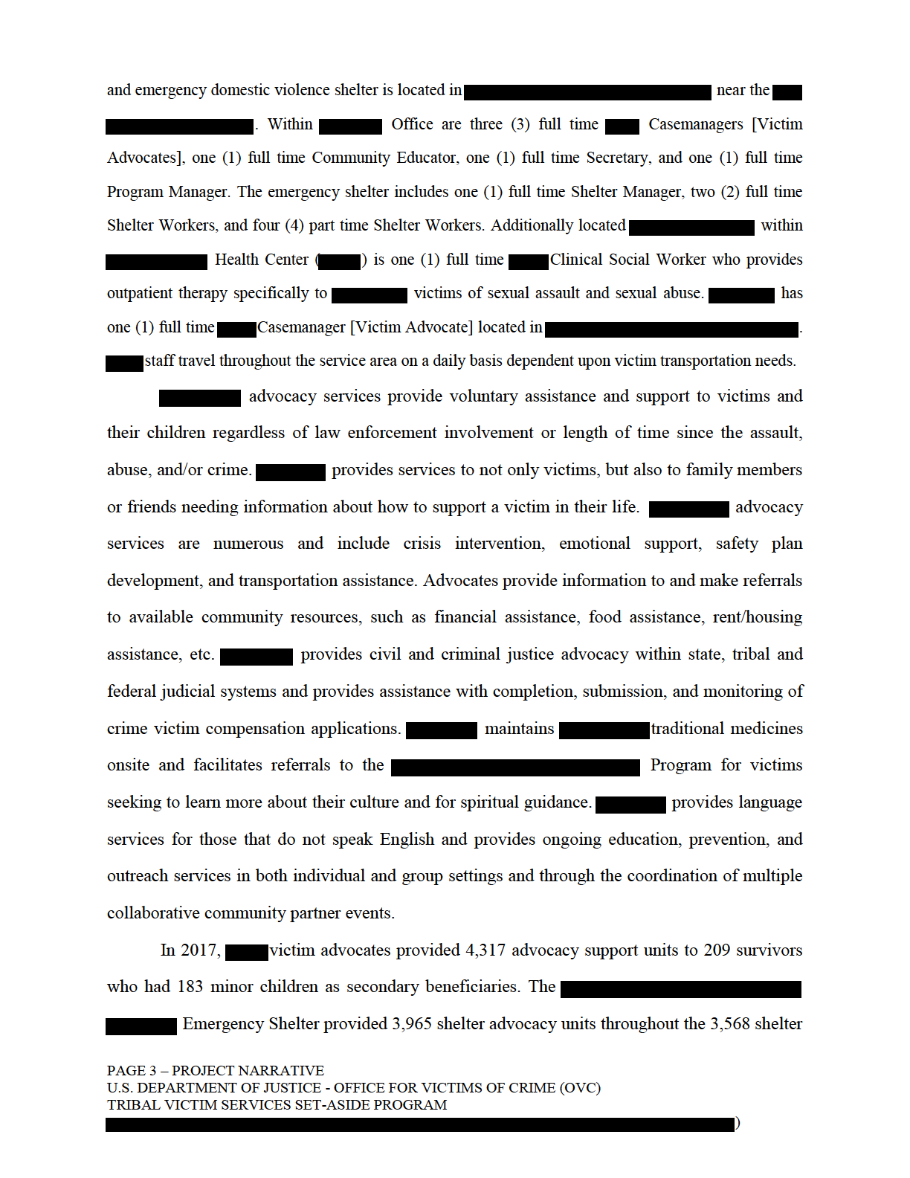
nights that were provided to 54 women and 42 children which are the highest numbers of shelter nights since the program opened in 2003 Also during 2017, == staff facilitated 169 individual and group education sessions and participated in 49 community events reaching a total of 14,761 individuals.

DESCRIPTION OF THE ISSUE:
While the Native American population as a whole remains critically marginalized and underserved within multiple measures of well-being nationwide, even more so are the tribal citizens that reside in rural and isolated geographical regions in ====. The need to sustain, expand, and enhance a comprehensive victim assistance program is clearly evidenced by == annual service delivery statistics and by victimization rates within the ===seven county service area.

Currently, --- operates only one of two existing tribally operated emergency Shelter within=== which sustains minimally sufficient staffing to ensure 24 hour a day victim access. This single coverage during evenings, nights, weekends, and holidays has led to challenges trying to effectively manage victim entries into shelter along with being available to assist with existing shelter resident needs.=== facility also encounters frequent power surges during the summer and lengthier power outages during the winter. The loss of electricity has created gaps in the security system that is rendered useless along with the loss of shelter resident perishable food when the refrigerator and freezer are inoperable. ===emergency shelter is lacking in culturally appropriate children's activities for use in a shelter room designated specifically for this purpose. === provides education, prevention, and outreach activities; although, struggles with the provision of support groups outside of === domestic violence shelter due to == insufficient time. Native American traditional beliefs value the connection to family and community which have been evidenced as critical towards the ongoing existence of tribal nations. The lack of Native American community healing groups is an observable gap; along with the lack of culturally appropriate clinically based victim support groups. Another gap recently identified is that there is only one existing clinical social worker within the entire ==service area that is certified to provide trauma informed outpatient therapy services. === provides over 15,000 miles annually of victim transportation assistance. One of ==vehicles was purchased in 2010 and has over 100,000 miles and is in need of replacement or the program may face having to reduce the availability of transportation assistance. Case manager [Victim Advocate] located in===is asked to providing victim service coverage in four of the seven counties within the tribe's service area.
ORPE does not have office in == to provide a confidential space to meet with victims or to foster the continued development of critical community collaborative relationships necessary towards meeting the multitude of victim needs resulting from victimization. === program additionally lacks the equitable distribution of Program Manager time among multiple grant programs that include grant monitoring, data collection, and data reporting mandates. currently === has 33 CAC's which utilize forensic interviewing and the multidisciplinary team approach to investigating child abuse.

_______________________________________________________
Example # 4
2018 Tribal Victim Services Set Aside Program
- Providing additional training for staff
- Purchase a vehicle for victim transportation
- Purchase emergency closet supplies
- Contract with a traditional healer
- Contract with four attorneys to support victims
- Subaward to hire a trauma-informed counselor
- Rent additional space for staff housing
- Expand victim compensation fund

CURRENT STATE OF VICTIM SERVICES:
ORPE is a community based tribal victim services program that has over years of experience providing services to both native and non-native victims of crime. is one of only two existing tribally-operated domestic violence shelters within---- and provides culturally specific, holistic, comprehensive, and trauma-informed programming including advocacy, individual/group/community education, and outreach services.
nights that were provided to 54 women and 42 children which are the highest numbers of shelter nights since the program opened in 2003 Also during 2017------ staff facilitated 169 individual and group education sessions and participated in 49 community events reaching a total of 14,761 individuals.

DESCRIPTION OF THE ISSUE:

While the Native American population as a whole remains critically marginalized and underserved within multiple measures of well-being nationwide, even more so are the tribal citizens that reside in rural and isolated geographical regions in----- The need to sustain, expand, and enhance a comprehensive victim assistance program is clearly evidenced by ====annual service delivery statistics and by victimization rates within the -----------seven county service area.

Currently, --ORPE operates only one of two existing tribally operated emergency
shelters within== which sustains minimally sufficient staffing to ensure 24 hour a day victim access. This single coverage during evenings, nights, weekends, and holidays has led to challenges trying to effectively manage victim entries into shelter along with---- being available to assist with existing shelter resident needs. ====facility also encounters frequent power surges during the summer and lengthier power outages during the winter. The loss of electricity has created gaps in the security system that is rendered useless along with the loss of shelter resident perishable food when the refrigerator and freezer are inoperable. emergency shelter is lacking in culturally appropriate children's activities for use in a shelter room designated specifically for this purpose. provides education, prevention, and outreach activities; although, struggles with the provision of support groups outside of---- domestic violence shelter due to insufficient time. Native American traditional beliefs value the connection to family and community which have been evidenced as critical towards the ongoing existence of tribal nations. The lack of Native American community healing groups is an observable gap; along with the lack of culturally appropriate clinically based victim support groups. Another gap recently identified is that there is only one existing clinical social worker within the entire service area that is certified to provide trauma informed outpatient therapy services. provides over 15,000 miles annually of victim transportation assistance. One of vehicles was purchased in 2010 and has over 100,000 miles and is in need of replacement or the program may face having to reduce the availability of transportation assistance.=== Casemanager [Victim Advocate] located in ---- is tasked with providing victim service coverage in four of the seven counties within the tribe's service area.==== does not have a satellite office in====== to provide a confidential space to meet with victims or to foster the continued development of critical community collaborative relationships necessary towards meeting the multitude of victim needs resulting from victimization. ==== multiple grant programs that include grant monitoring, data collection, and data reporting mandates.

====currently has 33 CAC's which utilize forensic interviewing and the multidisciplinary team approach to investigating child abuse. --------is made up of--- counties, which leaves counties without access to effective Forensic Interview Programs and often require victims to travel significant distances in order to access CAC services. has been involved in trying to develop CAC's throughout the tribe's service area for several years and has a MOU with the=== CAC which opened during===and the === CAC located in == which is yet to become operational. === has also worked collaboratively with community stakeholders in trying to secure an CAC with no success. Native American children and families are not receiving the best services afforded to those living near operational CAC's. This lack of equitable CAC access has had detrimental results affecting not only the legal outcome of a child abuse case, but more importantly to the child victim, and their ability to begin the healing process.

Additionally detrimental to tribal populations are the ongoing high rates of victimization. During 2017, === Law Enforcement (==) processed a total of 5,527 criminal complaints, 14 were for Criminal Sexual Conduct, 110 were for Domestic Violence / Non- aggravated Assault, 6 were for Aggravated / Felonious Assault, 8 were for Child Abuse / Neglect – Nonviolent, 12 were for Intimidation / Stalking, 20 were for PPO Violations, and 14 were for Missing Persons. The types of complaints identified above are only a mere fraction of all complaints that were received. Studies have shown that broad based advocacy services protect women and children from further violence by their assailants. Women who access these services are more effective in obtaining necessary resources, experience increased social support and quality of life over time, and experience less abuse over time. (Coalition Connection, March 2001) Non-native victim services programs are often not familiar with the historical trauma and cultural needs specific to Native American people that may result in a Tribal victim deciding to not seek services at all; therefore, it is critical that there be tribally operated victim services programming in addition to non-tribal programs having meaningful collaborative relationships with tribal nations.

PROJECT DESIGN AND IMPLEMENTATION DESCRIPTION

This application has been developed to respond to the emotional and physical needs of crime victims and to provide victims of crime with a measure of safety and security by providing trauma-informed and culturally sensitive services.

ORPE proposed to enhance “Services” delivery of domestic violence shelter services by creating two new part time Shelter Worker positions which will allow the shelter to schedule two, instead of only one, Shelter Worker during evenings, nights, weekends and holidays. Costs required for grant funded personnel include personnel, fringe, background checks, driver's license checks, and pre-employment drug screening. ==== additionally proposes to provide ===== Care Kits to be provided to shelter residents and their children upon discharge from the shelter. It is proposed to purchase replacement children's activities to be located in the domestic violence shelter's children's play area and proposes to purchase a facility generator for use during loss of electrical power to ensure the ongoing availability of domestic violence shelter security system protections and additionally so

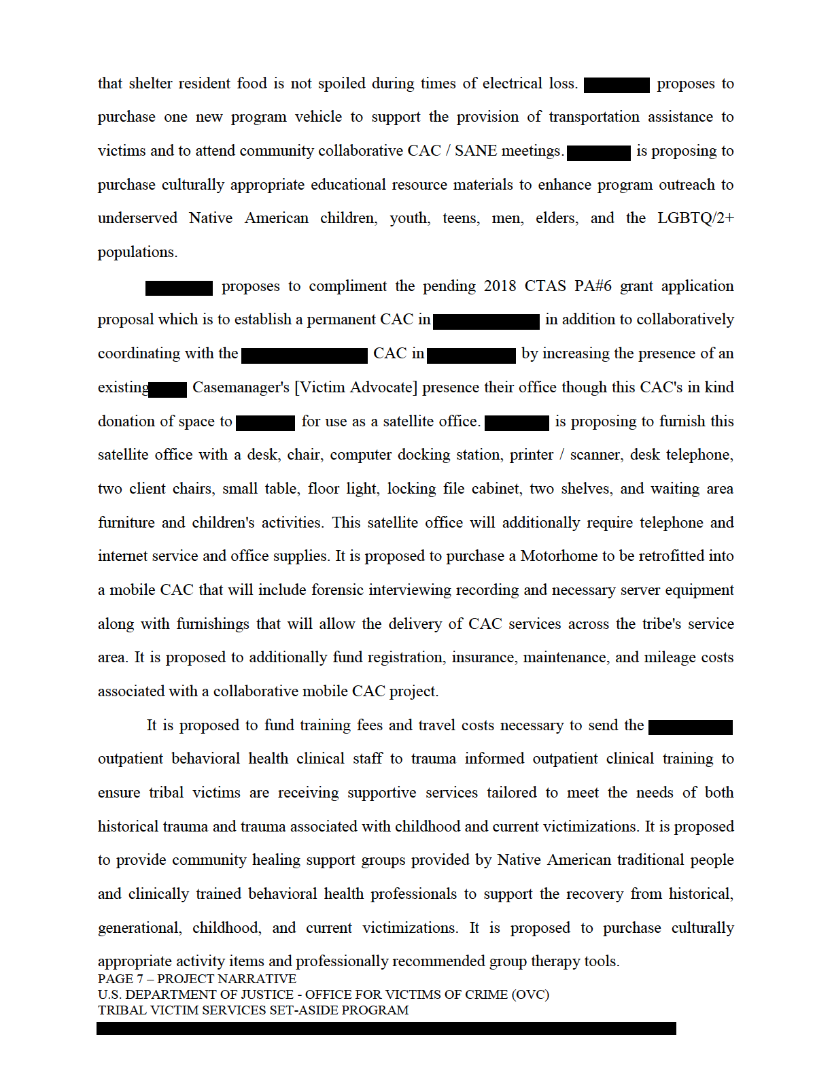
It is proposed to fund 50% of ==== Program Manager's Personnel and Fringe Benefit
costs beginning 10-01-2020 to support the grant management, data collection, and grant reporting mandates and additionally proposes to purchase policy and procedure software to ensure the standardization of all victim service program delivery processes. It is proposed to fund travel costs to allow attendance at grant mandated orientation and other grant mandated trainings and conferences and also mileage, hotel, and per diem necessary for=== staff to travel to community collaborative CAC and SANE / SART meetings within the ==== seven county service area.

DUPLICATION CHECK:

The ORPE did submit a 2018 CTAS grant application of which funding was requested for Purpose Area #6 and Purpose Area #7; although, did not submit a request for Purpose Area #5. The Purpose Area #6 application proposes to hire a Program Coordinator located within the tribal Prosecutor's Office who will be tasked with the establishment of a Child Advocacy Center in===. This position will coordinate the=== Multi- Disciplinary Team and the development of the proposed CAC Protocols and Policies. This PA#6 application proposes to provide training for the MDT to improve the response to child victims and reduce the trauma to the child victim by facilitating support services, prosecutorial based victim advocacy, and forensic interviewing of the victims. The Purpose Area #7 proposes to sustain shelter staff to ensure 24 hour victim access to culturally specific emergency domestic violence shelter services, and additionally proposes to facilitate the creation and implementation of an outreach and education plan designed specifically to reach the marginalized and underserved tribal elder population.

Exeple #3

Legal Assistance Program

- Hire a full time social worker
- Hire a full time legal advocate
- Hire 1 attorney licensed lawyer
- Hire a part time admin-assistant
- Contract with outside consultant to provide trauma-informed care
- Upgrade case management and data collection software
- Provision of victim services

- OVERVIEW
ORPE is the largest, federally recognized Indian Tribe in =======with --- is the largest, federally recognized Indian Tribe in=== and 1,417 enrolled tribal children under the age of 18. ===== Counties in an extremely rural region of===in the =====
The Reservation is impoverished and isolated. It lacks fully staffed tribal law enforcement, and emergency response times are measured in hours not minutes. Adequate job opportunities and basic utilities to all residents, like power and telephones are lacking. More than 63 percent of Reservation residents live on an annual income of less than $15,000 per year.

The Reservation is located==== cannabis-producing region in the USA. The remoteness of the Reservation, the absence of sufficient law enforcement officers, suitable climate, and low land prices, has attracted growers from all over, including dangerous criminals and drug cartels. With the cartels came an abundance of methamphetamines, fentanyl and heroin/opioids. Illegal opioids, together with staggeringly high opioid prescription rates, have created an opioid crisis in === community. People in ==== die from drug overdose (OD) at more than double the national rate and the county ranks out of counties for the highest rate of suicide in the state. In both counties, Native Americans have the greatest opioid overdose rates (Fig. 1). Deaths, hospitalization and emergency services visits due to drug OD are also greater on the Reservation than in surrounding communities. In zip code---the 2016 OD death rate was 170 percent greater than== and 114 percent greater than == Tribal Enrollment (June 2018)

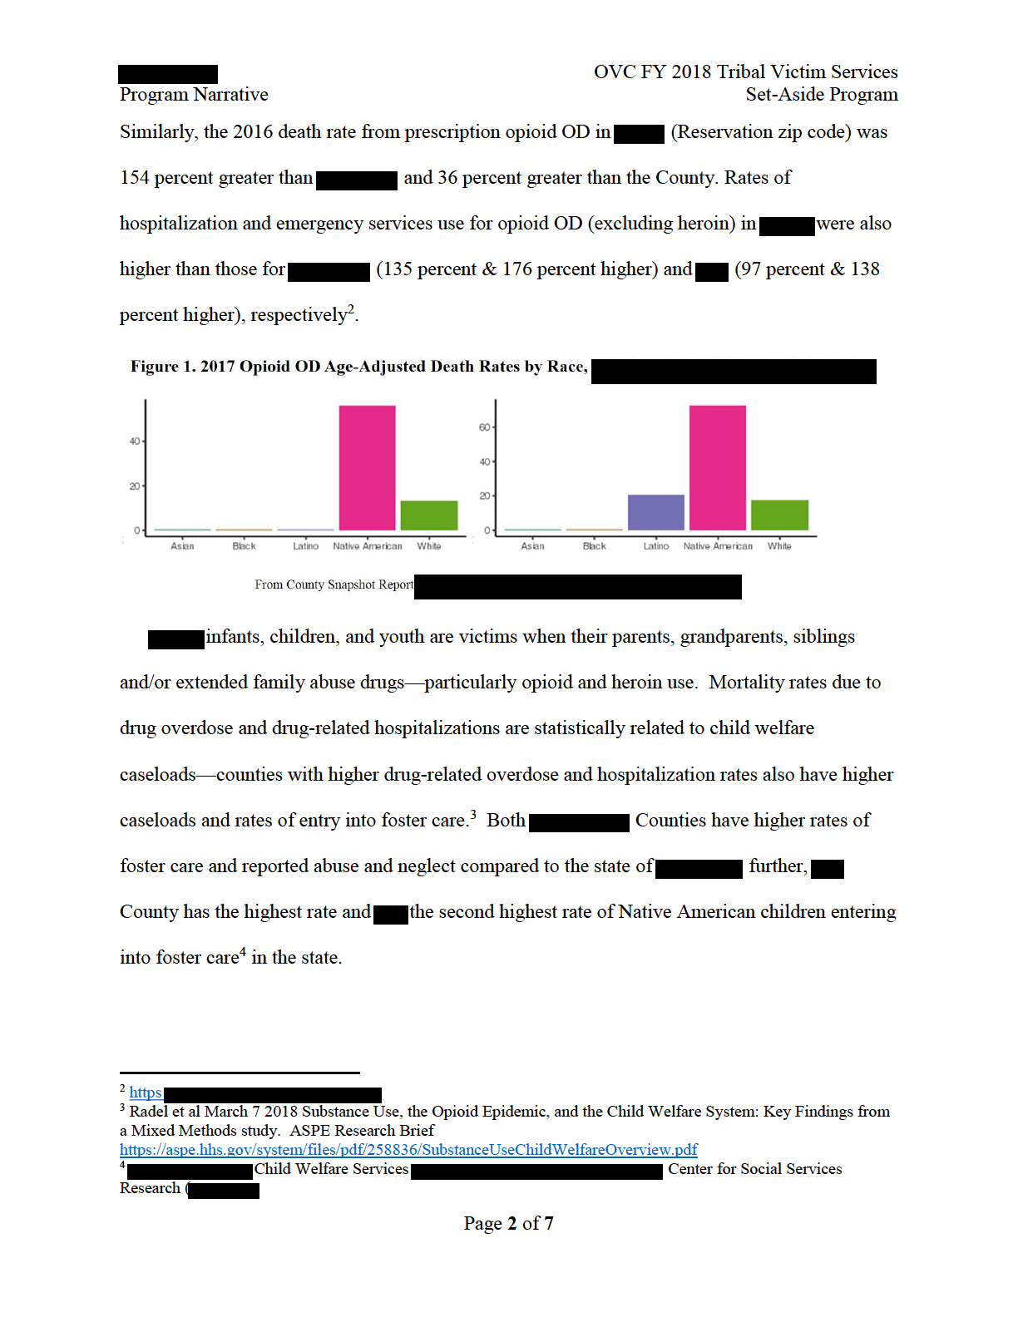
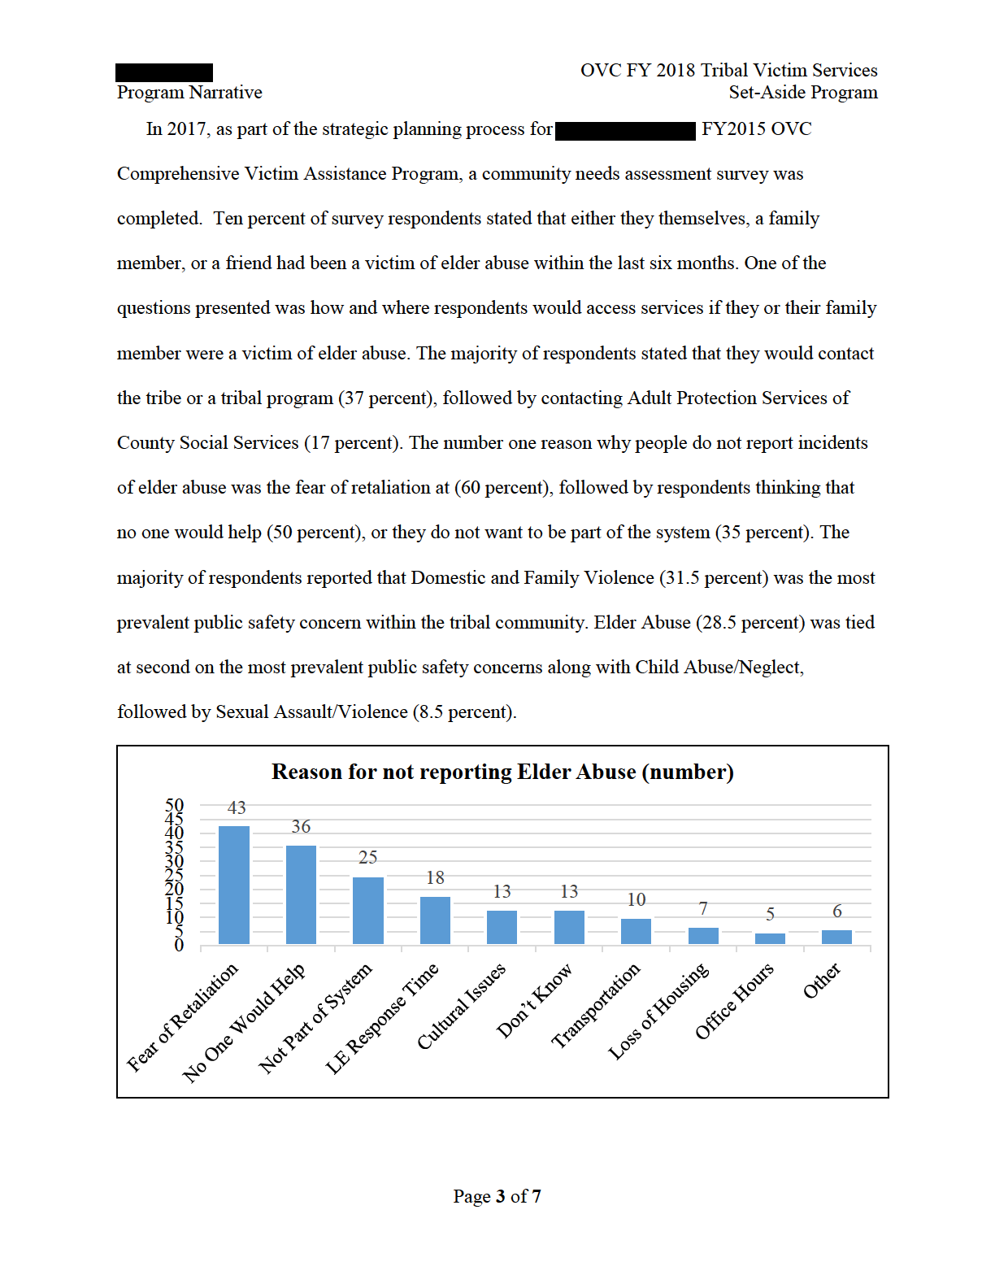
For the full year that the Elder Advocacy Program began offering services (2017), on average 14 clients a month were assisted, with one month having a total of 39 clients assisted (August- 2017) by one Elder Advocate. Of the services provided throughout the year, the number one service was home visit/assessments (51 times), followed by transportation to medical, APS, court and other appointments (47 times), and assistance/advocacy with applications for supportive referral and protection services (47 times). The type of victimization was primarily neglect, followed by physical abuse. Financial abuse was much harder to prove as victims were reluctant to disclose that they were victims of financial abuse by family members. Due to the remoteness of the upriver Reservation access to immediate victim and crisis intervention services is limited. Trips to the hospital is a six-hour roundtrip, plus the additional wait time to see a doctor. Because elder abuse/neglect services are primarily focused on the upriver Reservation this leaves the downriver area of the Reservation and the off-Reservation area== overlooked and provided for.

2. Current state of victim services.
(Explain who is currently serving crime victims in the area described above, and what services are currently available to victims.)

Program funding to develop the===Program. This was the first time that the Tribe was able to recognize the extent of the abuse/neglect of elder victims. The effort of== have produced specific data on elder victims, developed elder needs assessments, and addressed some of the gaps in services for === elder victims. The
Program was effective in identifying and addressing abuse/neglect of elders, but with only one staff member, it has been difficult to meet the extent of the needs of elder victims within === community.

The Tribe provides CWS to === tribal members across the United States. The Tribe has five Social Workers to service the entire CWS caseload. The caseload includes 269 child cases including reunification, family maintenance, delinquency, and guardianship; a total of 47 (or 17 percent) are cases that are within the Tribal Court. The Tribe’s CWS staff jointly investigate reports of child abuse and offer neglect and other services primarily within === service area.

The Social Workers are effective in co-managing cases within the county system, but do not have the capacity to properly respond to and case manage cases within the Tribal Court.

3.) Description of the issue.
(Describe the specific victim services/assistance issue(s) (that is, need, crime problems, or other conditions), that this funding will help you address. For example, you might describe gaps in service, populations of victims that are underserved or not being served, or conditions caused by continuing or emergent crime problems that the tribe(s) is currently not able to adequately address.)

==== children and elders are victims of abuse and neglect, this problem is exacerbated by the opioid epidemic. Illegal opioids, together with staggeringly high opioid prescription rates, have created an opioid crisis in ===community. == will address the specific issues related to abuse/neglect of elders, vulnerable adults (or “elder victims”), and children. The Tribe defines abuse/neglect of elder and child victims to include physical abuse, sexual abuse, psychological abuse, abandonment, isolation, neglect, self-neglect, and financial abuse has proposed funding in CTAS Purpose Areas #6 and 7 to (1) continue ====== Program and (2) to develop a trauma-informed Child Protection Team to improve crisis response and intervention in order to reduce the trauma experienced by child victims and their non-offending caregivers. We propose to expand these programs by providing court-based advocacy and victim advocacy services to support elders, child victims and their caregivers as they move through the legal system. child victims of abuse and neglect are primarily handled within the state Child Welfare Systems (“CWS”). These systems are overloaded with cases. Tribal families frustrated by the lack of response from the county often turn to the Tribal Court to establish a custody/guardianship of their minor aged relatives who have experienced abuse and/or neglect. The Tribe does not have adequate resources to respond to the rapidly expanding numbers of children spread across multiple counties that experiencing trauma due to abuse/neglect as a result of the opioid crisis. Previously, State Courts have taken on child welfare cases that would be more appropriately addressed in Tribal Court. In response to this problem, === Tribal Court has just initiated the first-ever joint-jurisdictional dependency court in == (Family Wellness Court—FWC) in collaboration with =====, === is in the process of developing a cognate FWC in ======. The services proposed here will support these two new innovative, cutting-edge collarborative FWC.
The == has was effective in identifying and addressing abuse/neglect of elders, but with only one staff member, it has been difficult to meet the extent of the needs of elder victims within == community. The Elder Advocacy Program is located primarily in the === , where elder victims are most isolated from available services. The current application to CTAS will continue this successful program; however, this leaves the other areas of the Reservation underserved. The services proposed here will expand these services into additional areas within ===== Territory.

4.) Project design and implementation description.
(Describe precisely what you propose to do if you are approved for funding. Your answer should directly relate to the needs/problem(s) you identified in #3 above)

The proposed Project will expand the services of the ==== Program by hiring one full-time Social Worker and one full-time Legal Advocate to work with elder/child abuse victims of crime within === tribal service area. These services will expand on current
services of the Elder Advocacy Program to increase services in ===. The Project will also hire one half-time Administrative Assistant to assist with data reporting, creating outreach material, and to assist with transportation. These positions will work within the tribal court programs department to provide crisis intervention, resources, and referrals to victims of crime upon first contact with the Tribal Court. The Project will have outside consulting services to provide trauma-informed care for victims of crime and incorporate traditional lifeways and practices into services offered to victims. The Project will upgrade the Tribe’s === case management and data collection software to update the current system to ensure proper tracking of data of victims of crime. The Project will also provide victim services to include but not be limited to emergency food/snacks, clothing, personal hygiene products, cleaning supplies, toiletries, household supplies, lodging, transportation costs, childcare assistance, relocations costs, locksmith services, and court-related fees.

5.) CTAS duplication check.
(State whether you submitted an application for victim services through the FY 2018 CTAS (Purpose Area 5, 6, or 7). If you did not, please state in a sentence that you did not. If you did, please indicate which purpose area(s) for which you applied. The Tribe applied for CTAS Purpose Areas 6 and 7.)

Note: [See GMS for the following additional materials required for Phase 2: Tribal Authorizing Resolution; Project Timeline; Capabilities and Competencies Statement; Performance Measures Table; Budget Detail Worksheet; Indirect Cost Rate Agreement; Standard Form 424; Financial Management System of Internal Controls Questionnaire; Signed Assurances and Certification Statements; Disclosure of Lobbying Activities; Disclosure of Pending Applications; and Additional Attachments]

Example 5

CTAS Purpose Areas 7
- Create a multidisciplinary team
- Hire a victim advocate

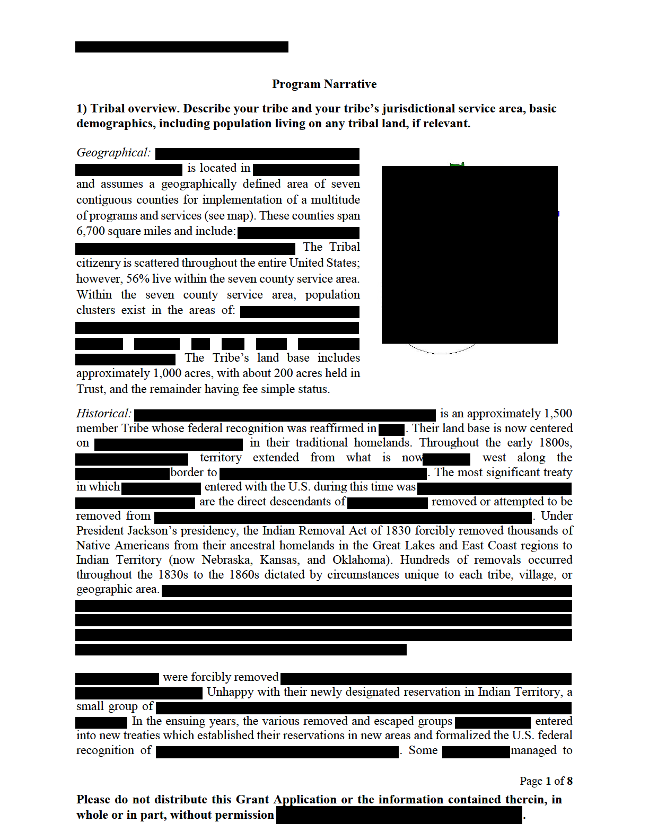
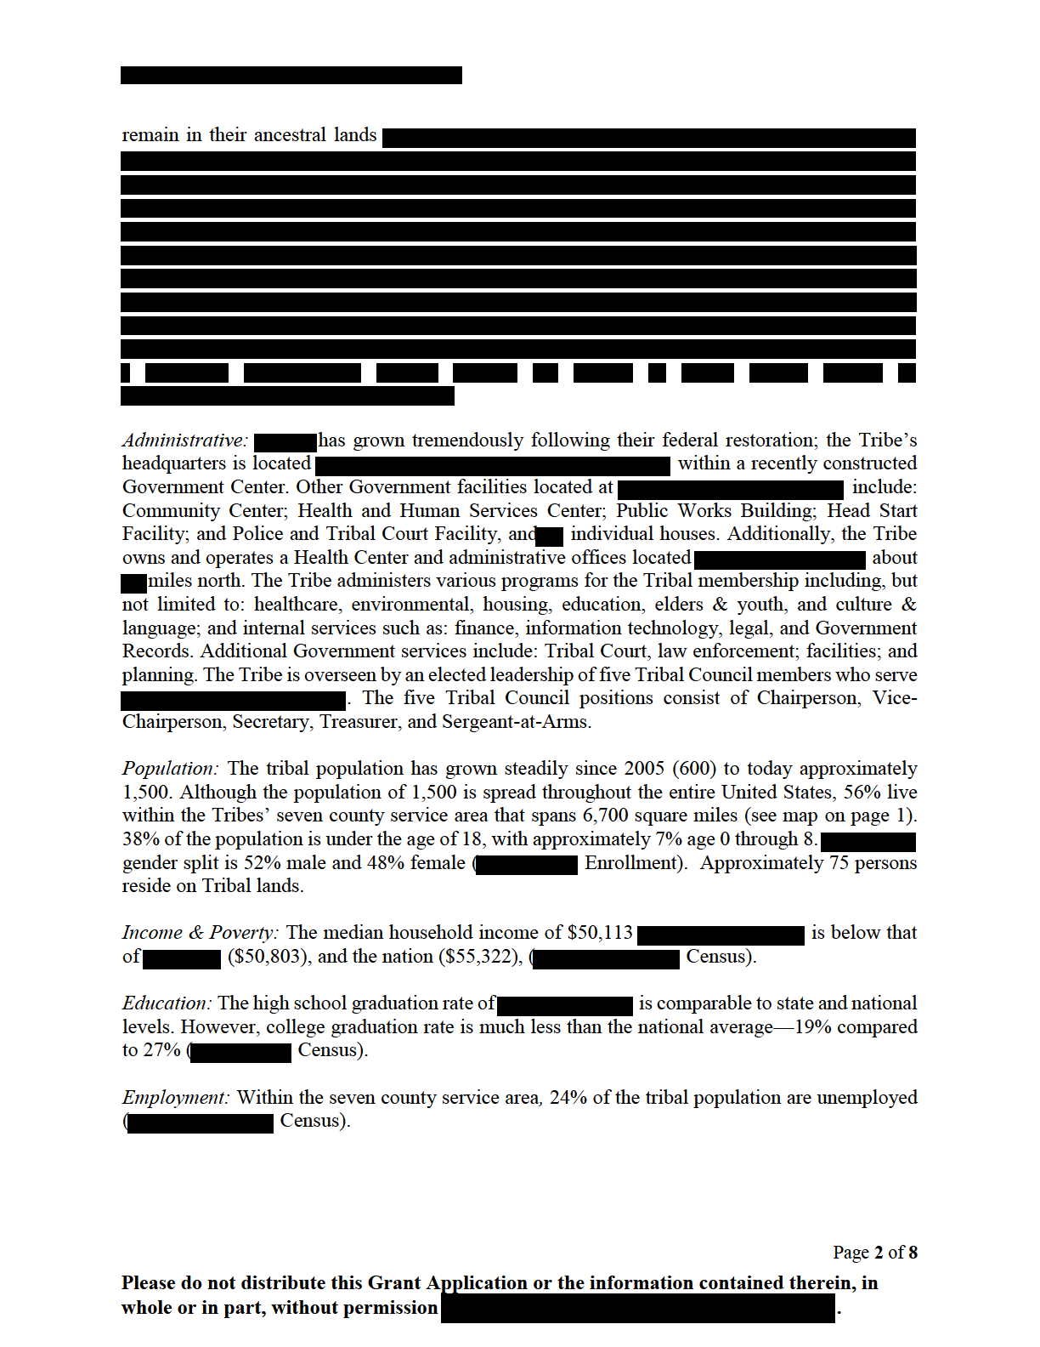
Language & Culture: English is the first language for almost all of ====, and governmental business is conducted in English. Other community interests focus on maintaining traditional lifeways and learning more about Tribal history.
- Current state of victim services.
(Explain who is currently serving crime victims in the area described above, and what services are currently available to victims.)

=== has a multi-disciplinary approach in providing victim services and this approach includes: Victim Services Department; Behavioral Health; Social Services; Membership Services; Culture Department; Police Department; and external partnerships to meet the needs of the community. The Tribe currently has established advocacy services and utilizes appropriate internal departments and staff resources. With funding provided through a CTAS award given by the Department of justice in 2015.
====has an established Domestic Violence Victim Advocate housed under Tribal Court. === Domestic Violence Code, which implements.==== Special Domestic Violence Criminal Jurisdiction, was officially adopted in==== and enacted in=== Tribal Court – Tribal Court staff is available to assist victims with filing petitions when requesting Personal Protection Orders. The court provides information regarding what specific information is needed to submit the requests based on Tribal Court Rules and Tribal Codes. The Tribal Prosecutor represents the People of the=== in Tribal Court when violations of==== Criminal Code and Civil Infraction Code occur on Tribal Trust Land. The Tribe has an established Domestic Violence Victim Advocate whom has developed and implemented specific programming and services to support Tribal Members who become victims of interpersonal violence and abuse. === Probation Officer provides appropriate support services to members when court ordered. Membership Services Department – Youth Specialists, in partnership with the Health and Human Services, Victim Services, and Culture Departments, provide prevention and intervention services for at-risk youth in an effort to strengthen cultural identity and develop resiliency skills and positive assets. Tribal Youth programs include:===========
Health and Human Services Department – Health and Human Services staff assists victims through their Behavioral Health and Social Services programs. Behavioral Health employs two case managers and three clinicians at ===clinics ===== .The program offers individual counseling, peer support groups, and referrals for external resources. Social Services’ staff includes a prevention worker who facilitates classes and presentations, such as ======= (parenting classes).
Additionally, the social services staff works in partnership with === Housing Department to provide rental/housing costs, energy, and utility assistance (i.e.,==)
Culture – The Cultural Specialists and Associates provide guidance and support for the Traditional Healer, Victim Services, and Health and Human Services. The Culture Department staff assisted in the development of the culture care kits. Additionally, staff help facilitate classes for the=====, and === curricula and assist the Traditional Healer with traditional healing activities, such as sweats. Child neglect, adoption and guardianship – The Tribe’s ability to stay actively involved in Indian Child Welfare Act cases remain an important priority. Establishing and adopting the Juvenile Justice Code and Child Protection Code have been necessary to protect the Tribe’s youth. External partnerships – In addition to internal Tribal services, === collaborates with non-Tribal partners to effectively reach the greatest number within the community. Some of these partners include:===== Food Bank of ===== YWCA of======= Sexual Assault Services of ====, and=== Department of Health and Human Services (===)

the early stages of a formalized domestic violence support program, === available data shows:
- Since the Victim Services Department was opened in === Tribal Court, the Domestic Violence Victim Advocate (DVVA) has handled a total of 84 cases. Of these, there are 8 Clients who were victims in 7 incidents that meet jurisdictional requirements for Special Domestic Violence Criminal Jurisdiction (SDVCJ) prosecution under Violence Code as adopted===and enacted===
- The Tribe’s Behavioral Health and Social Services Departments have experienced many cases in which interpersonal violence and abuse has been an issue when providing counseling and intervention services.
Domestic violence and sexual assault are not acceptable and are contrary to ===culture and values. Additionally, interpersonal violent crimes undermine the interests of Tribal nations, communities, and families in a time of growth, reclamation/revitalization, and healing.
Currently, ===Domestic Violence Code recognizes the seriousness of Domestic Violence/Sexual Assault (DV/SA) crimes and provides the survivors of these crimes the maximum protection from further violence. === recognizes the strength of the Tribal nation is founded upon healthy families, and that the safety of survivors of domestic violence and sexual assault must be ensured by immediate interventions implemented through law enforcement, prosecution, education, treatment, and other appropriate services. === leadership across the branches of the Tribal Government has prioritized a comprehensive and holistic approach to addressing domestic violence and sexual assault.
Specifically, === has identified the following needs and gaps in victim services that will be addressed through this grant:
- Lack of trauma-informed and crisis intervention training for == Departments that are part of the victim services multi-disciplinary approach.
- Lack of transportation services available to victims necessary for accessing services.
- Lack of space for an emergency supplies closet and additional emergency closet supplies.
- Lack of female traditional healing services and materials (excluding the four medicines— tobacco, sage, sweet grass, and cedar) to provide culturally-specific and supportive counseling for survivors of domestic violence and sexual assault.
- Expansion of access to licensed attorneys to provide legal advice, representation, and advocacy to victims.
- Expansion of trauma-informed counseling services within the greater community.
- Lack of physical program space to provide adequate victim services.
- Expansion of a victim compensation fund.

ORPE identified the following Project objectives:
- Enhance culturally-appropriate, trauma-informed care for Victim Services clients by providing additional training for staff involved in interdepartmental support services.
- Expand the Victim Services Department capacity to better serve service area by increasing the availability of services off-site through contracted positions and formalized partnerships in areas such as===
- Establish additional support services for Victim Services clients, including the Victim Services Emergency Supplies Closet and=== Tribal Court Victim Compensation Fund.

- Project design and implementation description.
=== has identified the following project design components that directly respond to the needs and gaps identified above:
- We propose to use funding for travel costs and registration fees for two OVC-related trainings per year, such as the Conference on Crimes Against Women or the National Indian Nations Conference: Justice for Victims of Crime, for staff from the Police and Culture Departments to increase our Tribal staff’s ability to comprehensively support victims. The OVC-related trainings help victims, victim service providers, allied professionals, and other interested parties. OVC provides federal funds to support crime victim compensation and assistance programs throughout the Nation, offers training for diverse professionals who work with victims, develops and disseminates publications, supports projects to enhance victims' rights and services, and educates the public about victim issues.

- We propose to use funding to purchase a vehicle for the purpose of transporting clients to/from services.
- We propose to use funding to purchase emergency closet supplies; all of which will support the victim services. === is able to provide emergency supplies on a case-by-case basis and outsource additional supplies from their partners, such as the ===. Utilizing grant funds, === Utilizing grant funds include, but are not limited to: feminine hygiene products, non-perishable food items, baby and toddler products, etc.
- We propose to use funding to contract with a Female Traditional Healer. Traditional healing is a holistic based approach of understanding of the interconnectedness of all life and the importance of balance and harmony in Creation. Our mind, body, spirit and emotions are all interconnected. === is achieved when all four parts of one’s being are in balance. Traditional healing is restoring of balance to the mind, body, spirit and emotions for a more balanced and harmonious path to healing and recovery in order to achieve mno bmadzewen. Implementing a female traditional healing service can incorporate culturally consistent practices into existing services and programs for survivors, as healing should not be separated from culture and spirituality. Native traditional healing practices and cultural enhancement activities are both core and complementary interventions in promoting wellness and long-term recovery. These practices and activities are interlaced throughout many behavioral health programs in Tribal Nations. A traditional healer can make use of community strengths by developing coordinated community responses with law enforcement, criminal justice, and health and human services while protecting confidentiality and reducing stigma.
- We propose to use funding to expand. === ability to contract with up to four licensed attorneys. These attorney’s will provide the necessary legal representation and advocacy to support victims. Currently, == Domestic Violence Victim Advocate has established a partnership with the======. === provides legal advice and representation to eligible clients residing in ===counties needing services and/or representation in foreign (county or state) courts
- We propose to use funds for a sub-award to=== in order to hire a 1.0 FTE. Trauma-Informed Counselor for=== Victim Services’ clients. Although ===has qualified counselors housed within the Behavioral Health program (HHS), they lack a Trauma Informed Counselor who specializes in supporting victims of violence and is able to travel off-site to provide counseling for survivors of domestic violence and sexual assault living throughout== seven county service area. Currently, === lacks the physical capacity to house and manage a counselor specializing in interpersonal violence trauma within their facilities, therefore == will formalize their partnership with ===. The Trauma-Informed Counselor will provide counseling services for victims and survivors of interpersonal violence. The counselor will participate as part of the Shelter, DV, Child Advocacy, and Sexual Assault team to provide additional case management services including assistance with identification and utilization of resources, triage cases, provide assistance to== Victim Services Department, assist in advocacy for victims, potentially including non-Native == shelter residents. This position requires cultural knowledge of Native American clientele. Additionally, we propose to provide pass-through funding for two shelters that fall within == 7 county service area and within population clusters of === membership. These shelters are previously established external partners that === Victim Services Department has worked with to provide services to all eligible clients. == formalize these partnerships through a sub-contract agreement (drafts are provided in the application attachments) to provide pass through funds to support the necessary services to meet the community and clients’ needs. These shelters have been identified as====,===, and =====provides programs designed to === increase the safety and wellbeing of domestic violence survivors and their children. The provides services that address domestic violence and dating abuse, sexual assault, and child sexual abuse services. === services are available to women and their children who have experienced or who are experiencing domestic abuse. == serves all women equally regardless of age, race, religious belief, ethnic origin, sexual orientation, disability, or socio-economic status. Along with providing emergency shelter, the === also offers an array of non-residential services to women and their children, including one-on-one case management and support groups. 7. We propose to use funding to rent additional space each year of the project to adequately house victim services staffing in a location that is geographically appropriate to meet the needs of the community. 8. We propose to use funding to expand the inadequate victim compensation fund that exists within== Tribal Government.

- Description of the issue.
(Describe the specific victim services/assistance issue(s) (that is, need, crime problems, or other conditions), that this funding will help you address. )
Nationally, studies indicate a high percentage of domestic violence incidents go unreported. The Tribe recognizes the National Indigenous Women’s Resource Center’s report, “Safety for Native Women: VAWA and American Indian Tribes,” which includes the findings that 4 in 5 Native women (84.3%) have experienced violence in their lifetime. As a small community currently in === seven county service area. Currently, === lacks the

- Description of Program:

OLAV Program is a Comprehensive Tribal Victim Assistance Program aims to increase the safety and support of victims of domestic violence, victims of sexual assault, child abuses and neglected, elders and their families who are victims of crime; especially child abuse and neglect and elder abuse. Our goal is to create a multi-disciplina1y team (MDT) that uses trauma informed practices in a victim centered, community approach that will help identify victim's needs and ensure that follow-up occurs to meet those needs. The program will also provide victims with a victim’s advocate that helps to provide services, improve access to existing services and case management support.

Our program will address the following specific issues:

- Increased communication across various systems (Tribal, State, Law Enforcement, Social Services, Education etc.) that serve crime victims will improve victim outcomes and reduce re-victimization.
- Creation of holistic case plans that meet each victim and their family's specific needs.
- Access and availability of culturally appropriate, trauma info1med services to crime victims, with a special focus on children and Elders.

According to the Bureau of Justice Statistics (BJS), Native American have higher rates of victimization than all other races. They also report that Native Americans experience violent crimes at a rate of twice that of the general U.S. population, and that Native Americans over age 55 experience 22 crimes for every 8 crimes experienced in the overall population. 1 Native American children have the third highest rate of victimization at 11 .6 per 1000.2 Even without these statistics, Tribes are aware that victimization rates are high in our communities. We see the results anecdotally as we complete family safety assessments. In our current child welfare caseload of 48 children, 46 of them have family or personal history of victimization. Furthermore, most of these victims, have not received any services whatsoever. Traditionally, criminal and abuse investigations have focused on the perpetrator and the prosecution of crime, often leaving victims with little support or assistance to meet their needs. A typical abuse investigation includes interviews of the victim and household members that get a “snap shot” of the reported event. MDTs provide child welfare agencies, adult protection agencies, law enforcement and court personnel holistic information from all providers. Instead of a “snap shot”, we get a multi-dimensional view of the needs, barriers and strengths of not only our victims, but also their families and support systems. By creating and implementing multi- disciplinary teams, we can assure that the victim stays the central focus of all investigations, focusing on our most vulnerable populations, our children and Elders. Providing a victim advocate will further ensure that victims can access culturally appropriate trauma informed services in a timely manner. Further complicating victim services in our community are jurisdictional issues. We are located on the------------------ border and jurisdictional issues often complicate victims’ access to services. Many crimes must have those issues solved prior to a victim receiving services and the process is complex and can take an extraordinary amount of time. In the meantime, victims may not have access to the services they need. A tribal MDT will help increase communication across the jurisdictions, as well as facilitate the delivery of services to victims and their families.
Our MDT will consist of representatives from the following agencies:
- Tribal and State Child Welfare Agencies
- Adult Protection Agencies
- Tribal and local Domestic Violence Agencies
- Tribal and Local Law Enforcement Agencies
- District Attorney’s offices
- Courts
- School districts
- CASA
- Probation
- Mental health and substance abuse providers.
- Other community agencies to be determined during planning.
The MDT will staff at least 30 cases over the next 3 years. The MDT staffing will assist the program in determining victim and family strengths, needs and barriers. The MDT will also help determine what community agencies can assist in meeting case plan goals and victim needs.
ODLS is dedicated to investing in long-term strategies to address our public safety, criminal and juvenile justice, and victimization issues in a comprehensive manner. We achieve this by developing protocols and procedures that reinforce our cultural norms, values, and the priorities established by our Tribal leaders with input from our community members. The Tribal Community and Justice Profile identifies domestic violence, including child abuse and elder abuse, substance abuse and the shortage of culturally appropriate resources for Native youth as a major concern for our community. In response, ODLS has successfully designed and developed the following programs, in addition to our general social service programs, to help support victims of domestic violence, child abuse and neglect:
- Orpe Victims Assistance Legal Services
- Legal Assistance for Victims of Domestic Violence / Sexual Assault
- Title IV-E Foster Care Services
- Juvenile Wellness Assistance Program
- Youth Program

2. Current or previous efforts:
The above-mentioned services are offered in addition to the following services offered to all tribal members:
- Child Welfare and ICWA
- Family Resource Center and Library
- Family Assistance and Support (General Assistance, IV-B prevention etc.)
- Education Services and Support
- Child Care Development Fund Services
- SEEDS (Sustainable Employment and Education Solutions) program
Currently our only victim services are offered through --- Domestic Violence/Sexual Assault program. With funds from the Office of Violence. Against Women, the Tribal Sexual Assault Service Program, Family Violence and Prevention Services Act and California Office of Emergency Services, we have been able to implement a program with 6 staff to offer services, support, prevention and outreach for our community. As a direct funded IV-E agency, we are now able to access services for children removed or those at risk of removal from their home. Our current child welfare/ICWA program has approximately 50 cases handled by one social worker and the program manager. Our family services staff also delivers services under Juvenile Wellness court. ORPE has grown into a robust program that is able to meet the needs of victims affected by DV/SA. For the most part, these services are for the “primary” victim. Elders and children are often described “secondary” victims in domestic violence cases. Without services to address all crime victims, there are large gaps in providing holistic services to our children, elders and families.

- Current Gaps:
Our data shows that while only 9% of the population is Native American in Baltimore County County, 48% of the population of foster care is Native American. In 2015 25% of the foster care population consisted of ----- Children. has only 503 enrolled members in Howard County and only 211 children, but represented 25% of the foster care population. The data also shows higher number of substantiations of abuse and neglect, lower rates of reunification and higher incidences of re-entry to foster care within 12 months for native children.
3 Even with these startling statistics, there are very few culturally appropriate services offered
to Native families in the foster care or any other system. Department of Health and Human Services (DN DHHS) officials cite availability and access to tribally centered services as the reasons.
Many of our children in foster care are also victims of crime; they have witnessed drug use and domestic violence, they have suffered abuse and neglect and many have been victims of sexual abuse as well. Parents in child abuse and neglect cases are treated often as criminal perpetrators, but children in the foster care system are not often treated as victims of crime. Foster care services focus on reunification and safety, but healing and wellness tends to be ignored in typical case plans. Believes using MDTs can provide the multiple agencies involved with our families the insight to create holistic plans that address historical trauma, primary and secondary trauma as well as the abuse and neglect issues that brought the family to our attention.
Elders and vulnerable adults are often in the same crisis as our children in the foster care system. There are even fewer resources and access is much more limited. Adult Protective Services agencies can only address situations in which the Elder or adult chooses to move forward with criminal charges, is willing to request a protective order or is so incapacitated they can no longer make decisions for themselves. Many of our vulnerable adults suffer from mental illness and struggle with day-to-day living activities. This contributes to their high victimization rates. Elder/Dependent Adult abuse is not referred for any kind of community response and often the Tribe is not even aware an abuse referral is made. Without a community response or MDT in place, our Elders and vulnerable adults remain lost in a system with little support or access to services. State crime victims’ funds exist, but the network to access them can be confusing and disbursement is through the district attorney’s office and Victim Witness offices. Due to current and historical trauma, many Native Americans are not comfortable accessing services through and state system, much less the court system. Even if a family can get through the Victim Witness agency process, the services are not trauma informed or culturally appropriate.
Victims and their families often fail to access services for a variety of reasons. Some of the barriers shared with our staff are:
- No knowledge of available programs or services
- Lack of transportation
- Unwillingness (often due to historical trauma) to access services from state systems
- Confusion regarding where and how to access services
- Poor awareness of eligibility requirements
- Lack of advocacy to address needs
- Existing trauma inhibits ability to follow through
- Difficulty with application and eligibility process
- Fear of retribution from perpetrator
- General lack of support to access services Although we currently have a complement of DV/SA services, with the exception of OVW
TSASP, all current---- DV/SA funding provides intervention for the primary victim, children and elders are often defined as secondary victims ( they can receive services but they are not considered a primary victim). Familiar Elder Abuse (outside of dv/sa) is not clearly defined or unallowable in any of our current programs. Vulnerable Adults/youth are often victims of crime, but do not meet the requirements for DV/SA services. Currently the Tribe has no program for providing services specifically to crime victims, except for DV/SA. Advocacy is often a task assigned to our social worker, who already has a caseload of 50 child welfare cases. The only funding source that is allowable to support any non DV/SA crime victims is our Title IV-B funds, which are very limited at less than $18,000/year and limited for child abuse and neglect cases. We often use these funds to pay for relative placements prior to foster care licensing and IV-E eligibility. This program funds supportive services and activities for prevention and intervention of child abuse and neglect, training, recruitment and retention for foster families and partner agencies and in home supports for children at risk of abuse or neglect. There are no salaries available and services are very limited. Currently, DV/SA victims are the only ones that can access quality services. Other crime victims are left with little services or supports to help them navigate the healing process.

- Identification and Prioritization of Problem:
Our community assessment has identified services to children, youth and elders as problem areas for quite some time. Each community assessment we have completed returns with similar results. Anecdotally, CFS staff collects information on clients that are ineligible to receive requested services and documents why they were ineligible. Our anecdotal information has shown that often children, elders and dependent adults are falling through the cracks. Although states have limited services for crime victims, they are difficult to access and in our experience, they do little to offer the victim true support. The state OVC funds are used to provide counseling, but do little to help families’ access services or help victims know what services are available in their area.
ORPE staff all collect monthly data that records the number and types of service contacts. Over the last 3 years, our service contacts have increased dramatically. Our elder abuse reports
grew from 14 in 2014 to 23 in 2016. Our overall service numbers rose from 316 to 381 in the same period. While these numbers may not seem dramatic, our staff of two is attempting to provide services to almost 400 people per year. This is in addition to our child welfare caseload. This data collection has helped the Tribe determine where more services and supports are necessary and it is clear that victim services are lacking for Native Americans in our community

Description of Program:
ORPE Victim Assistance Program will offer a two-pronged approach to service provision: Establishment of an MDT to facilitate a multi-dimensional view of our victims and families and the strengths, needs and barriers that exist and an advocate position, to provide support to Native crime victims. Our MDT will gather information from multiple sources and provide a coordinated community response for substantiated reports of child abuse and neglect, elder abuse and other crimes. The multi-dimensional view of an MDT allows the program to have a better idea of the strengths, barriers and needs of the victims and their families. The advocate/specialist will assist by providing necessary supportive services and case management to Native victims of crime. Supportive services may include but are not limited to:
- Case management
- Advocacy
- Safety planning
- Basic needs (food, clothing, shelter)
- Counseling
- Mental health services
- Transportation
- Assistance with state forms and/or program referrals
- Community agency and service referrals
- Home visiting
The program will be under the direction of our CFS Director and supervised by our Family Services Manager. It will employ one victim advocate/specialist, located at our CFS office, a satellite office located ½ mile from our main administrative campus. Our off site location allows for high confidentiality as victims access services. The location is co-located with our other services that include child welfare and family services, domestic violence and sexual assault, childcare, education, general assistance and other general tribal welfare and assistance programs. Program co-location offers crime victims a “one stop shop” to access the services they are eligible for and that are most appropriate to support the victim and their family. The advocate/specialist will work closely with all CFS, Tribal and Community resources to assure that identified needs are met in holistic, trauma informed, and culturally appropriate manner.

Goals and Objectives:
The purpose of our project is to develop our community’s response to crime victims and increase the access culturally appropriate, trauma informed services to Citizen crime victims and their families that are located within our service area.
Goal 1: Develop a ORPE/State multi-disciplinary team that will increase communication across the various systems that serve crime victims to help develop a trauma informed community response for crime victims, especially children, elders and vulnerable adults.
- Objective 1: By the end of Month 6, project staff will identify and invite community partners in our service area in both California and Oregon to participate in the policy committee. The policy committee will create policy and procedures that adhere to Tribal, State, and Federal laws regarding confidentiality
- Objective 2: By month 6, local agencies will be aware of the project and necessary MOU development will have started with local agencies (Social Services, Law Enforcement, District Attorney, etc.).
- Objective 3: By the end of month 12, at least one MDT meeting will be completed and meetings will continue at least bi-monthly through the project period.
Goal 2: To increase the accessibility to trauma informed, culturally appropriate victim services by creating holistic case plans, developed with information gathered from an MDT setting with input from the victim, service providers and local agencies.
- Objective 1: By month 6, project staff will create and begin distribution ofa survey of local victim service agencies to determine a menu (what and where local services are available) and how to access them. By month 12, outreach materials will be available that identify crime victim services, availability and eligibility.
- Objective 2: By the end of year 1 at the MDT, project staff will develop atleast one holistic case plan that addresses accessibility of crime victim’s services.
- Objective 3: By the end of Year 2, project staff will have developed service plans for 15 crime victims that offer services that increase access to available services in the community and when no community services are available, the project specialist will deliver support services as identified in question 5 above.
- By the end of Year 3, 30 clients will have received program services.

7 Plans to develop a new Program:
Our project creates a Tribal Multi-disciplinary team that while present in some form in both Oregon and California, it does not cross the jurisdictional boundaries of the border. This cross

IV. ACTIVITIES
- Activity 1: Contact client for follow-up after the incident report is filed.
- Activity 2: Review Lethality Assessment Reports and determine high risk offenders.
- Activity 3: Determine immediate need of victims and work with community resources to meet those
Needs.
- Activity 4: Address immediate safety needs of crime victims (replace broken locks, clothing for rape
Victims, etc..).
- Activity 5: Link victims to community contacts to assist victim with ongoing safety planning needs
assessments, and social services in the community setting.
- Activity 6: Link victims to community contacts to assist victim with ongoing safety planning needs as
assessments, and social services in the court setting.

V. IMPLEMENTATION TIMELINE FOR ACCOMPLISHING KEY GRANT ACTIVITIES
Activity Outputs | Position of Person Completing the Task | Due Date for the Completion

VI. INTENDED OUTPUTS (Products)
Victimization Type | Number

VII. INPUTS

VIII. DATA COLLECTION AND EVALUATION
Program evaluation will consist of data collected by the project specialist as they provide services to victims and work with the community to establish an MDT. We will collect data using our current case management software, regarding the number MDTs held, cases staffed, service plans created, service plans completed, revictimization rates and the actual services accessed by victims. We will also collect data on crime victims, including age, type of crime and disability status to evaluate if our targeted outreach services were effective. The data will be collected using our case management software and other case management tools such as file reviews. A successful project is defined by an increase in service knowledge and acquisition for victims, completed service plans, low revictimization rates and identifying if children and elders were the majority of our clients.

VIII. TRAINING AND TECHNICAL ASSISTANCE NEEDS
Training and Technical Assistance Needs: Our project specialist/advocate will participate in the OVCTTAC Victim Assistance online training. In our rural area, online training is a valuable tool for increasing skills and knowledge of staff. We also will encourage our project staff to apply for the Leadership Institute at the National Victim Assistance Academy. We may request TA for developing our resource survey for local victims’ services to assess what services are currently available in our community.

X. Need for Assistance:
Currently the Tribe has two staff that work specifically with children and Elders. The current caseload is approximately 50 CWS/ICWA cases. Our staff time is nearly fully allocated to managing the programs that are funded through our self-governance agreement and Title IV-E. It would not be possible for our current staff to add this project to their already overwhelmed workload. Current staff have some percent (10-30%) of time available to assist the project team, however, a full project with policy and procedure development and outreach to community and agencies and victims would not be possible.

IX. COLLABORATIVE ACTIVITIES / LEVERAGE RESOURCES
ORPE Community and Family Services has a number of collaborative partnerships, both internal and external that will be used to leverage resources to continue this project after the end of the grant period. Internally, we will collaborate with our newly approved IV-E program, our DV/SA program, our existing tribal service programs and our culture and language program. Externally, we have strong partnerships with University of Maryland Baltimore Washington Medical Center; DHHS and DHS, the main providers of services to children and elders in our local area. CFS has just started implementation of a direct funded IV-E foster care program. In three years, our program will be in full implementation and a successful grant project will have completed the planning and implementation of MDT’s. With the framework in place and MDTs already taking place, the ORPE along with our local social service agencies can continue the work that started by the grant project.

XII. Plans to develop a new Program:
Our project creates a Tribal Multi-disciplinary team that while present in some form in both Oregon and California, it does not cross the jurisdictional boundaries of the border. This cross jurisdiction MDT, along with a victims advocate, will increase access to services to crime victims and their families. Our project will utilize services and collaborations that are already in place, such as the connection between tribal social services and county/state social services. We already jointly respond and staff child abuse and elder/dependent adult abuse referrals. Law enforcement and the district attorney’s office have a process for communicating regarding crime investigation and prosecution. What we lack is a process that creates lines of communication between the silos of existing services. Social Services and law enforcement struggle to share information, victims’ service agencies are often not in the loop with the district attorney’soffice, the district attorney’s office is not in communication with social services. The data cited in questions 1 and 3 from the Bureau of Justice Statistics, the Dept. of Health and Human Services and California Dept. of Social Services supports our decision to focus on children and elders. Although services will be available to all non DV/SA crime victims, our outreach efforts will be focused on increasing knowledge, availability and access for services specifically for children and elders. The same characteristics that increase the victimization of children and elders are often the same barriers that inhibit access to services. Barriers such as transportation, communication and service awareness create more barriers for elders and children than they do for adults. Providing an advocate to assist clients in acquisition of services will create an impact that will remain after the end of the project. As community members are able to access services, more victims will be aware of available services.

XIII. SERVICE AND TRAINING AND TECHNICAL ASSISTANCE

- Publications, fact sheets, and model code
- Peer-to peer consultation
- Listerv communication
- Onsite TTA
- Distance learning TTA via teleconference, video conference, and email
- Interactive online training modules
- Webinars
- In-person training onsite and selected national conference centers

XIV. CAPABILITY

